How to create a

Virtual Environment

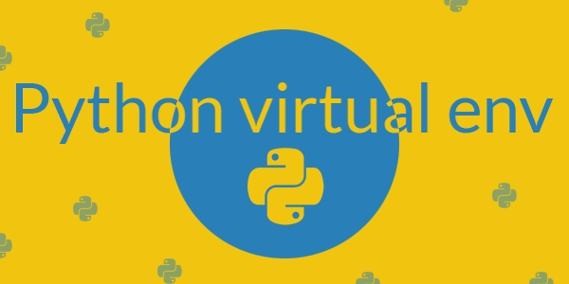

## **Introduction**[**¶**](https://docs.python.org/3/tutorial/venv.html#introduction)

Python applications will often use packages and modules that don’t come as part of the standard library. Applications will sometimes need a specific version of a library, because the application may require that a particular bug has been fixed or the application may be written using an obsolete version of the library’s interface.

This means it may not be possible for one Python installation to meet the requirements of every application. If application A needs version 1.0 of a particular module but application B needs version 2.0, then the requirements are in conflict and installing either version 1.0 or 2.0 will leave one application unable to run.

The solution for this problem is to create a [virtual environment](https://docs.python.org/3/glossary.html#term-virtual-environment), a self-contained directory tree that contains a Python installation for a particular version of Python, plus a number of additional packages.

Different applications can then use different virtual environments. To resolve the earlier example of conflicting requirements, application A can have its own virtual environment with version 1.0 installed while application B has another virtual environment with version 2.0. If application B requires a library be upgraded to version 3.0, this will not affect application A’s environment.

**Creating Virtual Environments¶**

The module used to create and manage virtual environments is called venv. Venv will usually install the most recent version of Python that you have available. If you have multiple versions of Python on your system, you can select a specific Python version by running python3 or whichever version you want.

To create a virtual environment, decide upon a directory where you want to place it, and run the venv module as a script with the directory path:

python3 -m venv tutorial-env

This will create the tutorial-env directory if it doesn’t exist, and also create directories inside it containing a copy of the Python interpreter, the standard library, and various supporting files.

A common directory location for a virtual environment is .venv. This name keeps the directory typically hidden in your shell and thus out of the way while giving it a name that explains why the directory exists. It also prevents clashing with .env environment variable definition files that some tooling supports.

Once you’ve created a virtual environment, you may activate it.

On Windows, run:

tutorial-env\Scripts\activate.bat

On Unix or MacOS, run:

source tutorial-env/bin/activate

(This script is written for the bash shell. If you use the **csh** or **fish** shells, there are alternate activate.csh and activate.fish scripts you should use instead.)

Activating the virtual environment will change your shell’s prompt to show what virtual environment you’re using, and modify the environment so that running python will get you that particular version and installation of Python. For examples

$ source ~/envs/tutorial-env/bin/activate

(tutorial-env) $ python

Python 3.5.1 (default, May 6 2016, 10:59:36)

...

>>> import sys

>>> sys.path

['', '/usr/local/lib/python35.zip', ...,

'~/envs/tutorial-env/lib/python3.5/site-packages']

>>>

**Managing Packages with pip**

You can install, upgrade, and remove packages using a program called pip. By default pip will install packages from the Python Package Index, <https://pypi.org>. You can browse the Python Package Index by going to it in your web browsers